How to add network printer in Ubuntu
--- Louis Lu, Aug 2016
System Settings → Printers

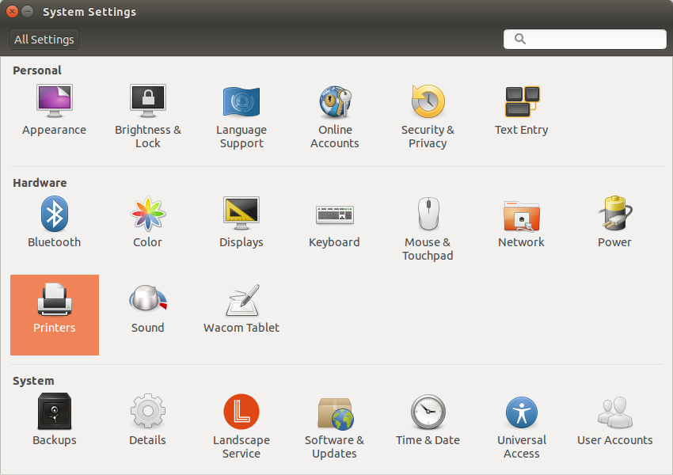

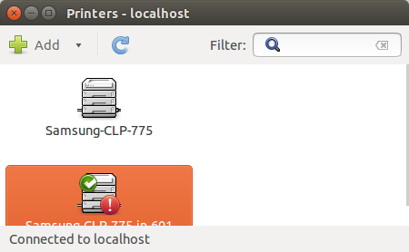
Click the Add button to add new printer

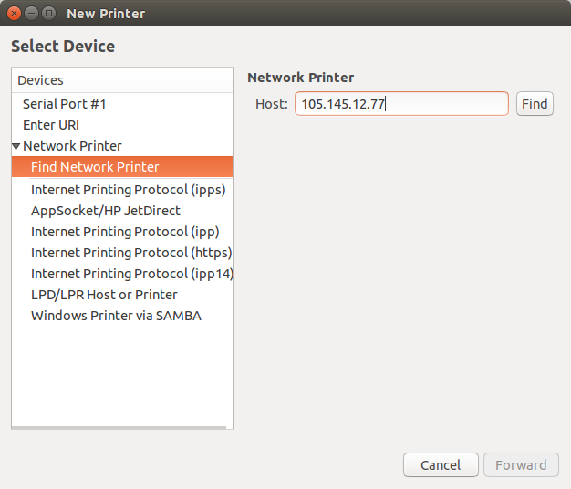
Select Network Printer → Find Network Printer → Enter the Host IP address → Find button.

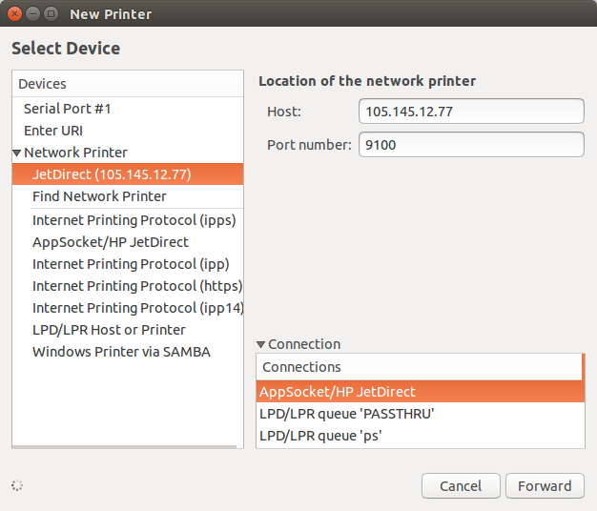
Port number: 9100
Connection: AppSocket/HP JetDirect

Forward and let it search
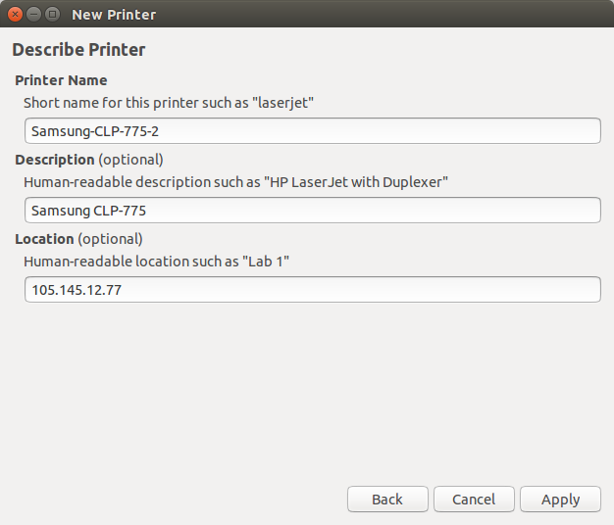
Type printer name, and Apply.

